1. Change the purple color of the app by this color : E5636E
2. In the Loading page have the back ground this color ( E5636E ) and ship ship written on it in white like this



1. Have a section for users to log into the app using their email for the tracking numbers feature , for the sign up page. It should be right after the loading screen and should look like something like this

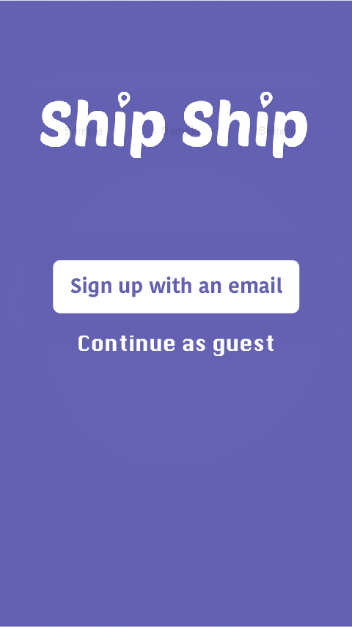

Find an API to retrieve data for email , I’ve looked into <https://rapidapi.com/search/email?section=all&amp;page=1> GIVE ME AN UPDATE ASAP I NEED THIS DONE. A similar app called shop has gmail integrated id like to have all emails. should not be too hard to scan a mailbox im sure you guys can figure it out.